Lab 01 Propositional Logic
Objective
Solving exercises from the textbook in chapter 1.1

Current Lab Learning Outcomes (LLO)
By completion of the lab, the students should be able to:

- understand propositional logic concepts and practice the truth tables.
Lab Requirements
Students allowed using their lecture notes in the lab in order to solve the exercises.
Lab Assessment
1- Divide students to groups and let them to solve the given example.
2- Discuss the answers with the groups and write on board the optimal solution.
Lab Description

- Which of these sentences are propositions? What are the truth values of those that are propositions?
- Do not pass go.
- What time is it?
- 2 + 3 = 5.
- 5 + 7 = 10.
- x + 2 = 11.
- 2^{n} ≥ 100
a) F b)F c)Yes, T d) Yes, F e)F f) F
- What is the negation of each of these propositions?
a) Jennifer and Teja are friends.
b) There is no pollution in New Jersey.
c) 2 + 1 = 3.
Solution: a) Jennifer and Teja are not friends.. b) There is pollution in New Jersey. c) 2 + 1 ≠ 3.

- Let p and q be the propositions p : It is below freezing. q : It is snowing. Write these propositions using p and q and logical connectives (including negations).
    - It is below freezing and snowing.
    - It is below freezing but not snowing.
    - It is not below freezing and it is not snowing.
    - It is either snowing or below freezing (or both).
    - If it is below freezing, it is also snowing.
    - Either it is below freezing or it is snowing, but it is not snowing if it is below freezing.
    - That it is below freezing is necessary and sufficient for it to be snowing.
a) p ∧ q b) p ∧ ￢q c) ￢p ∧ ￢q d) p ∨ q e) p→q f) (p ∨ q) ∧ (p →￢q g) q ↔ p

- Let p and q be the propositions “Swimming at the New Jersey shore is allowed” and “Sharks have been spotted near the shore,” respectively. Express each of these compound propositions as an English sentence.
a) ￢q b) p ∧ q c) ￢p ∨ q d) p →￢q e) ￢q → p f ) ￢p →￢q g) p ↔￢q
h) ￢p ∧ (p∨ ￢q).
solution: a) Sharks have not been spotted near the shore. b) Swimming at the New Jersey shore is allowed, and sharks have been spotted near the shore. c) Swimming at the New Jersey shore is not allowed, or sharks have been spotted near the shore. d) If swimming at the New Jersey shore is allowed, then sharks have not been spotted near the shore. e) If sharks have not been spotted near the shore, then swimming at the New Jersey shore is allowed. f) If swimming at the New Jersey shore is not allowed, then sharks have not been spotted near the shore. g) Swimming at the New Jersey shore is allowed if and only if sharks have not been spotted near the shore. h) Swimming at the New Jersey shore is not allowed, and either swimming at the New Jersey shore is allowed or sharks have not been spotted near the shore. (Note that we were able to incorporate the parentheses by using the word “either” in the second half of the sentence.)

- How many rows appear in a truth table for each of these compound propositions?
      - (q →￢p) ∨ (￢p →￢q)=(2²=4)
      - (p ∨￢t) ∧ (p ∨￢s) =(2³=8)
      - (p → r) ∨ (￢s →￢t) ∨ (￢u → v)= (2⁶=64)
      - (p ∧ r ∧ s) ∨ (q ∧ t) ∨ (r ∧￢t=(2⁵=32))
Solution: if there are n variable then there exists 2^{n} rows.

- Construct a truth table for each of these compound propositions.
a) (p ∨￢q) → q b) (p ∨ q) → (p ∧ q) c) (p ∨ q) → (p ⊕ q) d) (p ∨ q) ⊕ (p ∧ q)
e) (p ↔ q) ⊕ (￢p ↔￢r) f ) (p ⊕ q) → (p ⊕￢q)

solution
a) 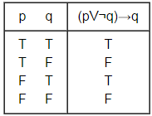 b) 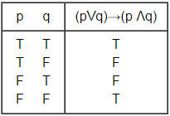

c) (p ∨ q) → (p ⊕ q) c) (p ∨ q) ⊕ (p ∧ q)
e) (p ↔ q) ⊕ (￢p ↔￢r) f ) (p ⊕ q) → (p ⊕￢q)

solution
c)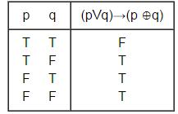 d) 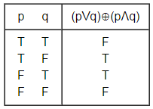

e) 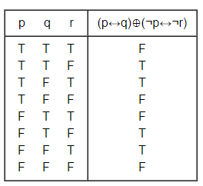f) 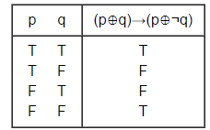

- Suppose that Smartphone A has 256MB RAM and 32GB ROM, and the resolution of its camera is 8 MP; Smartphone B has 288 MB RAM and 64 GB ROM, and the resolution of its camera is 4 MP; and Smartphone C has 128 MB RAM and 32 GB ROM, and the resolution of its camera is 5 MP. Determine the truth value of each of these propositions.
a) Smartphone B has the most RAM of these three smart phones.TRUE
b) Smartphone C has more ROM or a higher resolution camera than Smartphone B. TRUE
c) Smartphone B has more RAM, more ROM, and a higher resolution camera than Smartphone A.
FALSE (T ^ T ^F)
d) If Smartphone B has more RAM and more ROM than Smartphone C, then it also has a higher resolution camera. FALSE ( TRUE → FALSE)
e) Smartphone A has more RAM than Smartphone B if and only if Smartphone B has more RAM than Smartphone A FALSE ( FALSE↔ TRUE)
- For each of these sentences, determine whether an inclusive or, or an exclusive or, is intended. Explain your answer.
a) Coffee or tea comes with dinner.
b) A password must have at least three digits or be at least eight characters long.
c) The prerequisite for the course is a course in number theory or a course in cryptography.
d) You can pay using U.S. dollars or euros
a) Exclusive or: You get only one beverage. b) Inclusive or: Long passwords can have any combination of symbols. c) Inclusive or :A student with both courses is even more qualified. d) Either interpretation possible; a traveler might wish to pay with a mixture of the two currencies, or the store may not allow that.
- Write each of these statements in the form “if p, then q” in English. [Hint: Refer to the list of common ways to express conditional statements.]
a) It snows whenever the wind blows from the northeast.
b) The apple trees will bloom if it stays warm for a week.
c) That the Pistons win the championship implies that they beat the Lakers.
d) It is necessary to walk 8 miles to get to the top of Long’s Peak.
e) To get tenure as a professor, it is sufficient to be world famous.
f ) If you drive more than 400 miles, you will need to buy gasoline.
g) Your guarantee is good only if you bought your CD player less than 90 days ago.
h) Jan will go swimming unless the water is too cold.

a) If the wind blows from the northeast, then it snows. b) If it stays warm for a week, then the apple trees will bloom. c) If the Pistons win the championship, then they beat the Lakers. d) If you get to the top of Long’s Peak, then you must have walked 8 miles. e) If you are world-famous, then you will get tenure as a professor. f) If you drive more than 400 miles, then you will need to buy gasoline. g) If your guarantee is good, then you must have bought your CD player less than 90 days ago. h) If the water is not too cold, then Jan will go swimming.

